**Task 1: PL/SQL**

You’ve been given unnamed PL/SQL code below. Copy and paste the code in SQL Commands, enter employee number 7369.

DECLARE

lv_empid emp.empno%type;

lv_firstname emp.ename%type;

lv_deptname dept.dname%type;

BEGIN

SELECT e.empno, e.ename, d.dname

INTO lv_empid, lv_firstname, lv_deptname

FROM emp e, dept d

WHERE e.empno = :g_empid

AND e.deptno = d.deptno;

dbms_output.put_line ('The employee: ' || lv_firstname || ' is the department: ' || lv_deptname || ' ');

EXCEPTION

WHEN no_data_found THEN

dbms_output.put_line('The employee: ' || :g_empid || ' is not in this Company.');

END;

So, above is piece of code that now we’ll try to understand different components and what they do.

|  |  |
| --- | --- |
| PL/SQL Code | What is it? |
| Lv_empid | e.g. this is **user defined** variable |
| Emp.empno%type |  |
| SELECT … INTO |  |
| SELECT e.empno, e.ename, d.dname  ~~INTO lv_empid, lv_firstname,~~ ~~lv_deptname~~  FROM emp1 e, dept d  WHERE e.empno = 7369 ~~:g_empid~~  AND e.deptno = d.deptno; |  |
| :g_empid |  |
| dbms_output.put_line |  |
| dbms_output.put_line  || lv_firstname || |  |
| dbms_output.put_line  ' is the department: ' |  |
| EXCEPTION |  |
| no_data_found |  |
| *apex_application.g_print_success_message := 'The employee: ' || :g_empid || ' is not in this Company.';* | This is for application builder – its useful! |

**Task 2: PL/SQL**

Type in and Run the following code in the SQL Command tool:

DROP TABLE emp CASCADE CONSTRAINTS;

CREATE TABLE emp AS SELECT * FROM scott.emp;

DROP TABLE temp CASCADE CONSTRAINTS;

CREATE TABLE temp AS SELECT * FROM scott.emp;

DELETE FROM temp;

In the following example, you find the first employee who has a salary over 2500 and is higher in the chain of command than employee 7499:

1. Type in and Run the following code in SQL Command:

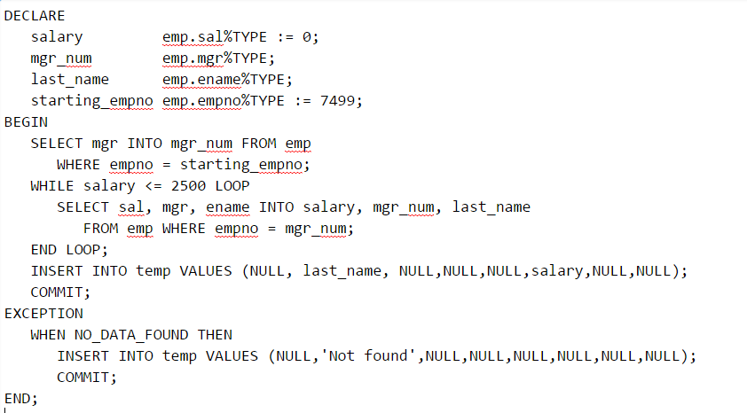

1. Now test this code. Write a statement to select all data from a temp table. The output should be:

